This submission template is a convenient document for you to provide your work and your answers for Lab 2. This submission template is intended to be used in conjunction with the Lab 2 Instructions document. The instructions document illustrates how to correctly derive the answers, explains important theoretical and practical details, and contains the complete set of instructions for this lab.

Name:

Donghang He

Date:

2019/11/9

Conversion tables are included below for your convenience, if you opt to perform the binary-to-decimal or decimal-to-binary conversions by hand. If you opt to use a calculator to perform the conversions, it is not necessary to use the conversion tables provided.

|  |  |  |  |  |  |  |  |  |  |
| --- | --- | --- | --- | --- | --- | --- | --- | --- | --- |
| Power of 2 |  | 128 | 64 | 32 | 16 | 8 | 4 | 2 | 1 |
| Bit |  |  |  |  |  |  |  |  |  |
| Amount Remaining |  |  |  |  |  |  |  |  |  |

|  |  |  |  |  |  |  |  |  |  |
| --- | --- | --- | --- | --- | --- | --- | --- | --- | --- |
| Power of 2 |  | 128 | 64 | 32 | 16 | 8 | 4 | 2 | 1 |
| Bit |  |  |  |  |  |  |  |  |  |
| Cumulative Amount |  |  |  |  |  |  |  |  |  |

**Section One - IPv4 Network Identifiers and Addresses**

2. For the following, indicate what its network identifier is, in binary.   
  
199.102.234.31/22  
199 –> 1100 0111

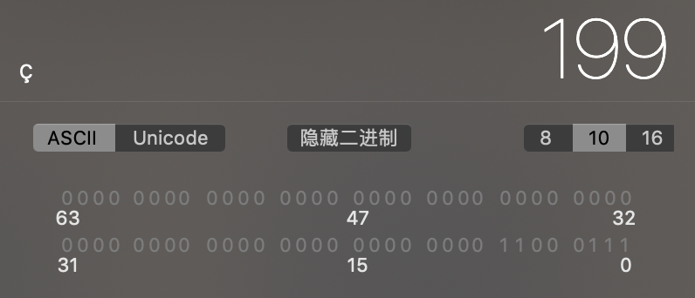

102 -> 0110 0110

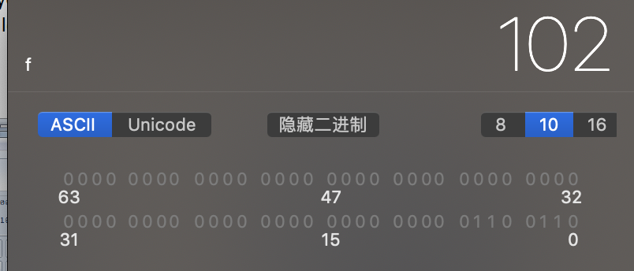

234 -> 1110 1010

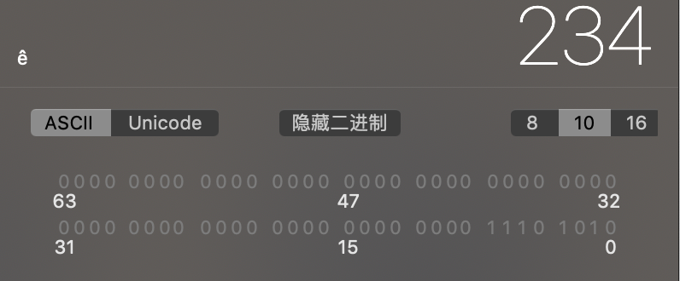

31 -> 0001 1111

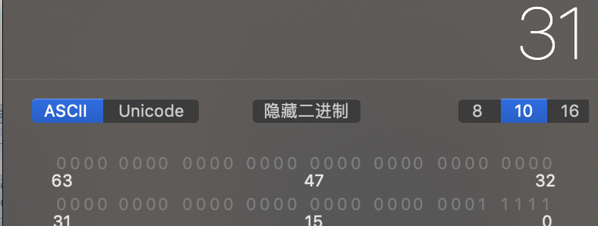

So the network identifier is 22 bits and address is 1100 0111 0110 0110 1110 10

4. For each of the following examples, extract the network address and express it in dotted decimal notation. Keep in mind that for IPv4 addresses given in binary, you will need to extract the network identifier, then follow the process as in step 3. For identifiers given in CIDR notation, you will first need to convert the IP address to binary, extract the network identifier, then follow the process in step 3.

00001010 01110111 00010111 10101010 (25 bits for network identifier)

00001010 -> 10

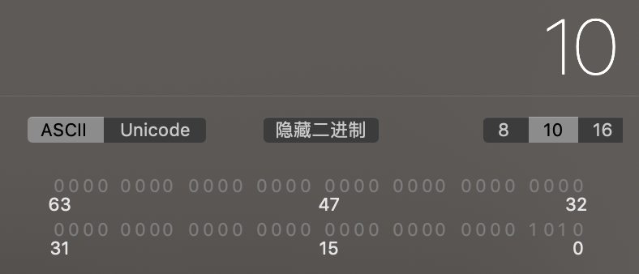

0111 0111 -> 119

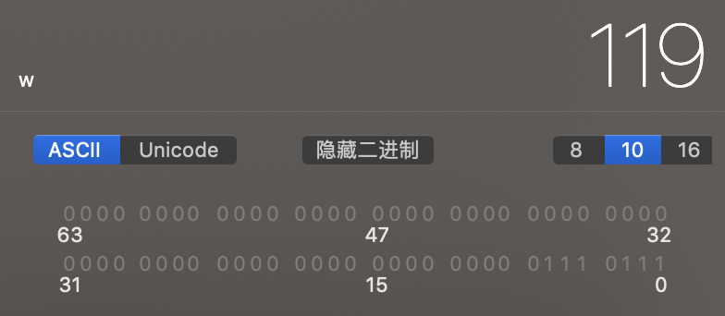

0001 0111 -> 23

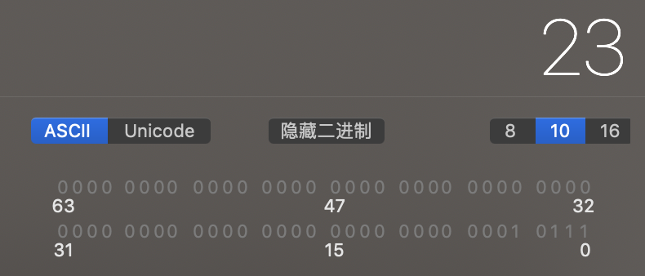

1000 0000 -> 128  
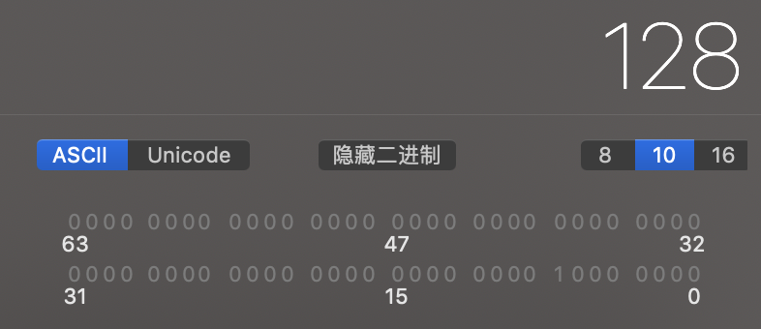

The network identifier is 25 bits and the address in dotted decimal notation is 10.119.22.0

74.119.98.141/19

74 -> 0100 1010

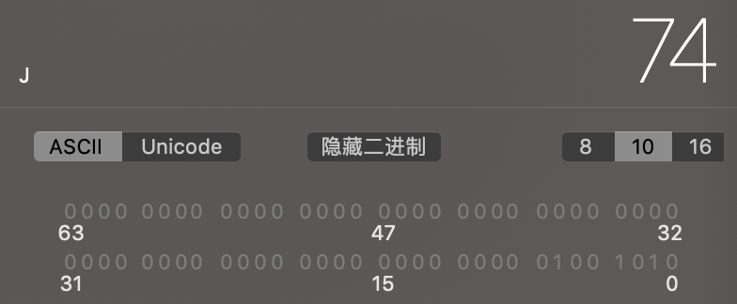

119 -> 0111 0111

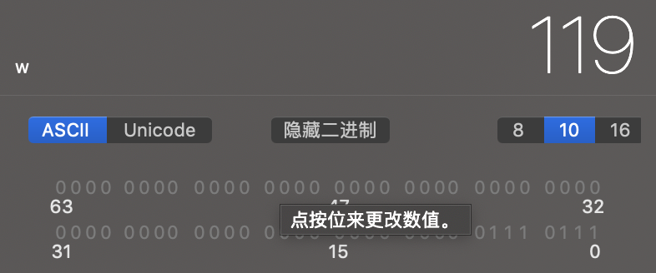

98 -> 0110 0010

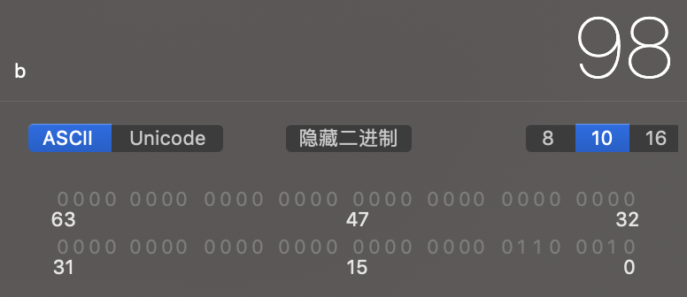

141 -> 1000 1101

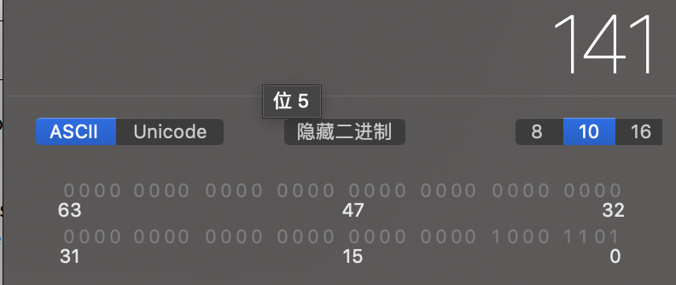

So the network identifier is 19 bits and the address is 01001010 01110111 011 and in dotted decimal is 74.119.96.0

6. Now you give it a try by taking advantage of this shortcut. Represent the network address in dotted decimal notation for the following.   
  
208.73.211.230/25  
a. we copied the first three octets, 208.73.211 since they were fully spanned

b. converted the last octet, 230, to binary, which is 1110 0110

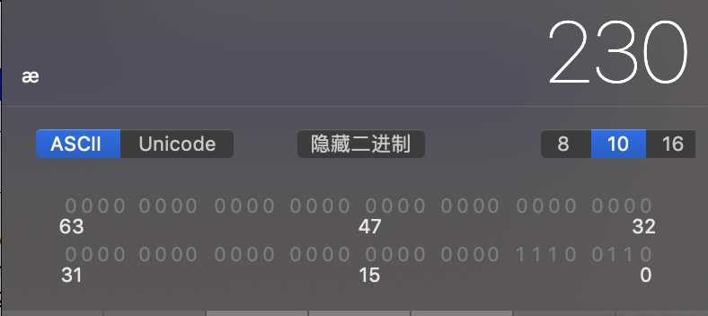

c. extracted the first bit of that number which is 1

d. appended 0s to the bits to arrive at 1000 0000

e. converted that back to decimal, which is 128  
f. arrived at the network address for 208.73.211.230/25, which is 208.73.211.128

8. Now you give it a try by taking advantage of both shortcuts. Represent the network address in dotted decimal notation for the following, making sure to take advantage of the shortcut mentioned in step 5 and in step 7.

71.74.42.231/15  
a. we can see that 15 bits fully spans the first octet, partially spans the second octet, and does not span the third and fourth octet at all.

b. So we can simply copy the first octet, and zero out the last two octets, arriving at 71.X.0.0 Now we just need to calculate X.

c. converted 74 to binary, which is 0100 1010

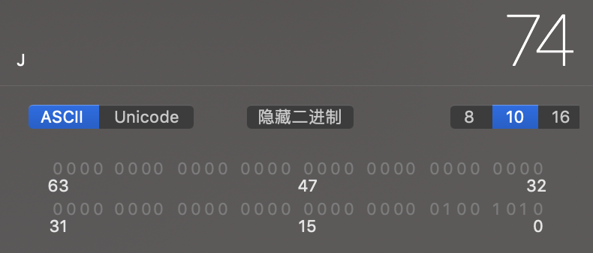

d. extracted the first seven bits of that number, which are 0100 101

e. appended 0s to the bit to arrive at 01001010

f. converted that back to decimal, which 74

g. arrived at the network address for 71.74.0.0

**Section Two - Network Comparison by Humans**

If you choose to perform portions of the assignment in different sittings, it is important to *commit* your data at the end of each session. This way, you will be sure to make permanent any data changes you have made in your curent session, so that you can resume working without issue in your next session. To do so, simply issue this command:

COMMIT;

We will learn more about committing data in future weeks. For now, it is sufficient to know that data changes in one session will only be visible in that session, unless they are committed, which makes the changes permanent in the database.

**SAVING YOUR DATA**

10. For the following pair of CIDR entries, determine if they are on the same network as each other. Show your work for full credit.   
  
209.237.160.185/15  
209.236.15.34/15

237 -> 1110 1101

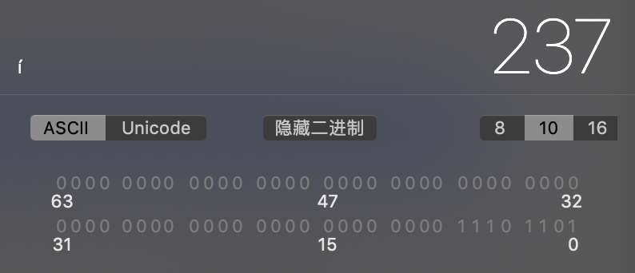

Network address: 209.236.0.0

236 -> 1110 1100

Network address: 209.236.0.0

So they are on the same network  
  
11. Five IPv4 addresses are given below, some in binary, and some in dotted decimal notation, along with the number of bits used for the network identifier. Your task is to group the addresses that are in the same network. Show your work for full credit.

74.208.88.242/20  
01001010 11010000 01010101 00001101 (20 bits for network identifier)  
01001010 11010000 01110101 11001100 (20 bits for network identifier)  
74.208.117.239/20  
74.208.1.19/20

88 -> 0101 1000

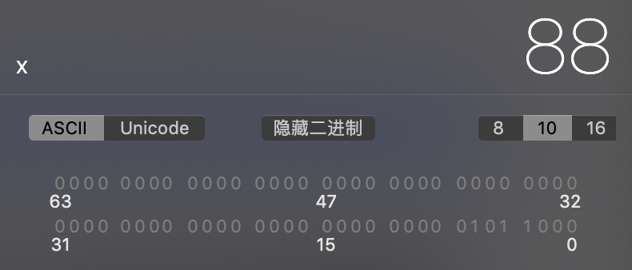

Network address: 74.208.80.0

01001010 1101000 01010000 00000000 ->network address: 74.208.80.0

01001010 1101000 01110000 00000000 ->network address: 74.208.112.0

117 -> 0111 0101

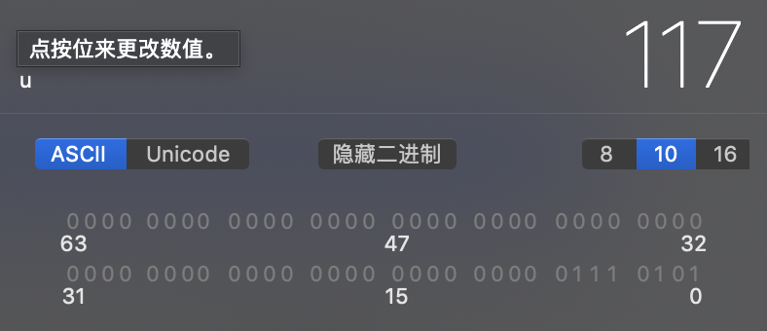

Network address: 74.208.112.0

Network address: 74.208.0.0

So first and second are the same group and the third and fourth are the same group.

**Section Three - Network Comparison by Computers**

13. For the CIDR entry below, list its subnet mask as a binary number.  
  
10.2.9.33/17

1111 1111 1111 1111 1000 0000 0000 0000

15. You give it a try with the following CIDR entry.   
  
23.3.96.50/19

Use the lookup table below to convert the partial octet for the given CIDR entry (if any).

|  |  |  |  |
| --- | --- | --- | --- |
| 00000000 = 0 | 10000000 = 128 | 11000000 = 192 | 11100000 = 224 |
| 11110000 = 240 | 11111000 = 248 | 11111100 = 252 | 11111110 = 254 |
| 11111111 = 255 |  |  |  |

1111 1111 1111 1111 1110 0000 0000 0000

255.255.224.0

17. Now you give it try with the following two examples.  
  
 1010  
& 0101  
0000  
 1111  
& 0111  
0111

19. Now you have a chance to perform the same operations as computers and devices to calculate the network address. See the CIDR entry below:  
  
137.254.120.47/25  
  
Using the same methodology as in step 18, calculate the network address for this entry. The steps you need to perform are to:  
a. convert the address in the CIDR entry to binary.  
b. calculate the subnet mask for this entry.  
c. perform the bitwise AND operation between the two to calculate the network address in binary.   
  
In addition to binary, show the network address in dotted decimal notation after it has been calculated.  
 1000 1001 1111 1110 0111 1000 0010 1111

&1111 1111 1111 1111 1111 1111 1000 0000

1000 1001 1111 1110 0111 1000 0000 0000

Network address: 137.254.120.0

21. Now you have a chance to try out the methodology used in step 20 with a similar scenario. Imagine that that the only network adapter on a computer has an IP address of 63.240.110.201 and that its network identifier spans 21 bits – 63.240.110.201/21. Further imagine that the computer wants to send a message to some other computers with the following CIDR entries.

63.240.110.201/21 -> 63.240.104.0  
  
63.240.110.219/21

0011 1111 1111 0000 0110 1110 1100 1001

& 1111 1111 1111 1111 1111 1000 0000 0000

0011 1111 1111 0000 0110 1000 0000 0000

63.240.104.0 on the same network

63.240.104.12/21

0011 1111 1111 0000 0110 1000 0000 1100

& 1111 1111 1111 1111 1111 1000 0000 0000

0011 1111 1111 0000 0110 1000 0000 0000

63.240.104.0 on the same network

63.240.102.35/21

0011 1111 1111 0000 0110 0110 0010 0011

& 1111 1111 1111 1111 1111 1000 0000 0000

0011 1111 1111 0000 0110 0000 0000 0000

63.240.96.0 on the different network

67.119.61.37/21

0100 0011 0111 0111 0011 1101 0010 0101

& 1111 1111 1111 1111 1111 1000 0000 0000

0100 0011 0111 0111 0011 1000 0000 0000

67.119.56.0 on the different network  
  
First calculate the sending computer’s subnet mask and network address by using the methodology listed in step 20. Then, for each of the CIDR entries above, use the methodology listed in step 20 to determine if each entry is on the same network or a different network than the sending computer.

22. In a paragraph or two, explain in your own words how the use of a subnet mask and the bitwise AND operation enables a computer to determine if another IPv4 address is on the same network, and why this method is well suited to computers.

First the computer converts the IPv4 address into binary and then do the AND operation with the subnet mask to calculate the network address.

Last, do the bitwise AND operation between the new network address with its own address. If the answer is same as its own address they are on the same network.

Your lab submission will be evaluated according to the following rubric.

|  |  |  |  |
| --- | --- | --- | --- |
|  | **Letter Grade** | **Qualities Demonstrated by the Lab Submission** | **Grade Assigned** |
| **Answers and Methodology**  **Measures the correctness and completeness of the answers and methodology used for lab steps** | A+ 🡺 100 | The answers, and answer justifications where required, are entirely complete and correct for all steps. The methodologies used to derive the answers are entirely applicable to the given problems, and are implemented correctly, for all steps. There are absolutely no technical or other errors present. |  |
| A 🡺 96 | One insignificant technical or other error is present, but otherwise the answers, and answer justifications where required, are entirely complete and correct for all steps. Excluding the insignificant error, the methodologies used to derive the answers are entirely applicable to the given problems, and are implemented correctly, for all steps. |
| A- 🡺 92 | One or two technical or other errors are present, but otherwise the answers, and answer justifications where required, are entirely complete and correct for all steps. Excluding the one or two errors, the methodologies used to derive the answers are entirely applicable to the given problems, and are implemented correctly, for all steps. |
| B+ 🡺 88 | The answers, and answer justifications where required, are complete and correct for most steps. Likewise, the methodologies used to derive the answers are applicable to the given problems, and are implemented correctly, for most steps. |
| B 🡺 85 | The answers are correct or almost correct for most steps. Some answer justifications may be missing or incorrect, but most are present and correct where required. The methodologies used to derive the answers are applicable and implemented correctly for most steps. |
| B- 🡺 82 | The answers, and answer justifications where required, are complete and correct for about ¾ of the steps. Likewise, the methodologies used to derive the answers are applicable to the given problems, and are implemented correctly, for about ¾ of the steps. |
| C+ 🡺 78 | The answers are correct or almost correct for about ¾ of the steps. Some answer justifications may be missing or incorrect. The methodologies used to derive the answers are applicable to the given problems, and are implemented correctly, for about ¾ of the steps. |
| C 🡺 75 | The answers for about half of the steps are either missing or incorrect. Likewise, the methodologies used for about half of the steps are either inapplicable to the given problem, or are implemented incorrectly. Some answer justifications are missing or incorrect where required. |
| C- 🡺 72 | The answers for most of the steps are either missing or incorrect. Likewise, the methodologies used for most of the steps are either inapplicable to the given problem, or are implemented incorrectly. Some answer justifications are missing or incorrect where required. |
| D 🡺 67 | The answers for almost all of the steps are either missing or incorrect. Likewise, the methodologies used for almost all of the steps are either inapplicable to the given problem, or are implemented incorrectly. Some answer justifications are missing or incorrect where required. |
| F 🡺 0 | The answers for virtually all of the steps are either missing or incorrect. Likewise, the methodologies used for virtually all of the steps are either inapplicable to the given problem, or are implemented incorrectly. Some or all answer justifications are missing or incorrect where required. |

Use the **Ask the Facilitators Discussion Board** if you have any questions regarding how to approach this lab.

Save your assignment as ***lastnameFirstname_lab2.doc*** and submit it in the *Assignments* section of the course.

For help uploading files please refer to the *Technical Support* page in the syllabus.

* + Use ALTER TABLE statements to add the foreign key constraints to the tables after all of them have been created.